# The Early Childhood Inclusion Center of Excellence logo of just “us” in blue with the sun above it.

# Little SPARK: Simple Play Adaptations to Reference for Kids

## Time Tracker Mini

**Materials:** TheSand Timer Set Package includes 6 sand timers: 1 minute, 3 minutes, 5 minutes, 10 minutes, 15 minutes, and 30 minutes.

**Who Might Benefit?**

Those who benefit and/or are motivated by visual schedules and/or visual passage of time to transition smoothly between activities, stay on task, and complete tasks.

**Image:**

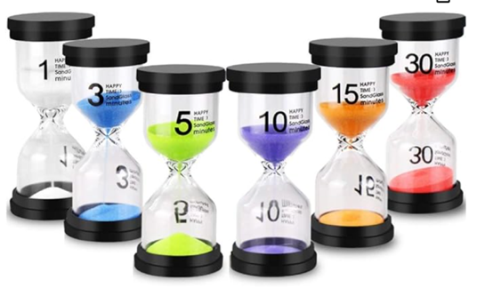

**Why Use?**Provides an opportunity to understand the passage of time, prepare for transitions, and stay focused on tasks for a set amount of time.

|  |  |
| --- | --- |
| **Instructions for Use:** | **Adaptation Ideas:** |
| **Environmental Considerations**   * Portable and accessible in all environments.   **Positioning**   * Place on table or floor where the child can see the timer during tasks completed in a variety of positions.   **Basic Play/Use 🡪 Extended Play/Use**   * Use to set time limits on specific activities. 🡪 Play “Guess How Long It Will Take” with various activities.   **Play/Use with Others**   * Timers can be incorporated into centers to allow exploration of the passage of time or used during circle time activities. | **Stabilize It**   * Place Velcro, Dycem, or shelf liner beneath the timer to secure to or stabilize on any flat surface.   **Simplify It**   * Break down tasks into smaller timed pieces.   **Contain It**   * Place timer in small, shallow container to decrease possibility of tipping over.   **Add Sensory Cues**   * Place against solid color backdrop.   **Communication Support**   * Add a visual schedule, token board, or verbal prompt to remind child why the timer is being used.   **DIY Alternatives**   * [Glitter Timer](https://www.instructables.com/Calm-Bottle-aka-Glitter-Jar/) (When the glitter settles, time is up!) * [Soda bottle sand time](https://www.instructables.com/Soda-Bottle-Sand-Timer/)r from Instructables. |

### Words to Encourage Play/Use

|  |  |  |
| --- | --- | --- |
| **First**  A black arrow pointing to the number 1 in a list of 1, 2, and 3. | **Done**A child with a thumb up slightly pointed toward themself and a green circle with a white checkmark next to the child. | **Wait** Child sitting in chair with clock next to them |
| **StopRed light lit up on a traffic signal** | **GoGreen light lit up on a traffic signal** | **Help**A child kneeling on his knee and another child reaching toward the kneeling child. |
| **My Turn A child pointing to themself.** | **Your TurnA hand pointing to a child.** | **TimeA clock with arrows pointing at the time.** |

*”Adaptations” adapted from: Haugen’s Modes for Adapting Toys based on materials from the "Let's Play" Project at the University of Buffalo

***PCS is a trademark of Tobii Dynavox, LLC.  All rights reserved.  Used with permission.***